# ECEN 350 Project: DC Power Supply with Current Limit

# (12/20/2018)

Contents

Introduction 1

DC Power Supply Project Grading 1

DC Power Supply Specifications 4

Parts and Materials 4

Suggested Design Procedure 6

Design/Implementation Details 7

Performance Characterization 10

### Introduction

Our ECEN 350 project is to design and construct a fixed output **DC Power Supply** with a current limit. You are to choose the desired output voltage of your DC power supply, within a 2.5 V to 9.0 V range, by selecting appropriate resistor values for a non-inverting amplifier stage. Two-person teams are recommended for this project, although the project can also be done individually. **No three-person teams are allowed for this project**. Many job interviews involve detailed technical questions on student projects, so striving to understand the details of your project betters your job prospects. **Each member of a two-person project team will receive the same score for this project**, based on a team **project report** submitted to I-Learn. So **only one report needs to be written and submitted per team, with the cover page designating both team members**.

### DC Power Supply Project Grading

30% of your team grade for your DC Power Supply Project is determined by measured performance values to be included in your project report, with the remaining 70% determined by the quality and completeness of project report.

**Project Report**

A future employer or coworker may very well read your project report, so write it with that end in mind. Project team members are to coauthor a single report including the **Discussion and Conclusions** section. **Only one report needs to be submitted per team, with the cover page designating both team members**. A good report will include all of the sections mentioned below and will utilize figure and table numbers and captions along with complete and grammatically correct sentences with correct spelling and punctuation. **Do not include explanatory text from this document or the grading rubric in your project report as that is not professional**.

**Cover Page**: Include class, Project title, and author or authors.

**Introduction**: Introduce your project so that someone unfamiliar with this project can understand what it is you designed and constructed. Include an introduction that is more than one sentence along with the following specifications for your specific power supply:

* Mention a supply that can be AC or DC powered.
* Desired DC Output Voltage.
* Short Circuit protected, mentioning current limit value.
* LED power indicator including measured turn-on voltage.

**Theory of Operation**: Your Theory of Operation should include the following explanations in your own words:

* Purpose of diodes D1 and D2 along with capacitor Cf.
* Purpose of diodes D3 and DZ1.
* Purpose of the LM385 2.5 V Voltage Reference Diode and op-amp U1-A.
* How resistor R5 and npn transistor Q1 together limit the current through M1 to the desired current limit value.
* How op-amp U1-B along with MOSFET M1 produce a regulated output voltage.

Explaining how the various circuits of your project work in your own words is an opportunity to demonstrate your understanding of the various electronic circuits.

**Your explanatory text is to be authored by you and your other team member, and not a copy of someone else’s work, including explanatory text pulled from this document**.

In addition, your **Theory of Operation** section is to include a **schematic diagram of your complete circuit using LTspice**, incorporating all component values. Include component types such as 1N4007 for the rectifier diodes, LM358N for the op-amp IC, LM385-2.5 for the 2.5 V voltage reference. For the Zener diode in the LED indicator circuit, document on you schematic the Zener breakdown voltage you used for the Zener diode, such as 10V or 12V, since specific Zener diode part numbers don’t clearly denote the associated Zener breakdown voltage. Similarly, include the color of the indicator LED you choose for LED component type. Schematic diagrams of the individual circuit functions can also be included in your report. **Also include your name or names on all your LTspice schematics, using the Text option available in the Edit pull-down menu.** Your **Theory of Operation** section is to also include calculations for your current limit value, along with resistors Rbias2, R1, and Rf, and filter capacitor Cf. **You don’t need to include the test points shown in Figure 4 below for your power supply schematic**.

**Measured Performance**: Include a section in your project report for measured performance that includes the following items:

* Measured Output voltage versus load current graph, including data points for no load, and for ILoad ≈ 0.9ILimit. Include a figure number and caption, along with axis labels and appropriate units.
* **Table 2** Completed with Measured and Calculated Values including units along with a table number and caption.
* Oscilloscope screen capture of output voltage ripple measurement with input voltage ripple, i.e. Vfiltered, also displayed. Output voltage ripple is to be measured at 0.9ILimit with the cursors indicating the peak-to-peak output voltage ripple value used for your ripple rejection calculation. Include the CH. 1 and CH. 2 settings control so that a 1X probe setting can be verified for the displayed output voltage ripple.

**Discussion and Conclusions:** Include a section in your project report for Discussions and conclusions that includes a photograph of your completed power supply project, along with appropriate figure number and caption. Also include **lessons learned**, future improvements, etc., that you deem useful to mention.

**Project Report Grading Rubric**

|  |  |
| --- | --- |
| **Report Item** | **Points** |
| **Cover Page**   * Include class, Project title, and author or authors. | 2/2 |
| **Introduction**   * Project introduction of at least two sentence. (2 points). * Specifications. AC/DC powered (1 point), DC Output Voltage (1 point), Short-Circuit protected including current limit value (1 point), Measured turn-on voltage for LED Indicator (1 point). | 6/6 |
| **Theory of Operation (TOP):**   * Purpose of diodes D1 and D2 along with capacitor Cf. (4 points) * Purpose of diodes D3 and DZ1. (2 points) * Purpose of the LM385 Voltage Reference Diode and op-amp U1-A.   (4 points)   * How resistor R5 and npn transistor Q1 together limit the current through M1 to the desired current limit value. (4 points) * How op-amp U1-B along with MOSFET M1 provide a regulated output voltage. (4 points) * Schematic diagram of your complete circuit including component values along with Figure Number and Caption and name or names of team members. (10 points total for schematic or schematics, 2 points for Figure number and captions, 2 points for names) * Calculations, including current limit, resistors Rbias2, R1, and Rf, filter capacitor Cf. (8 points total for calculations, 3 points for current limit, 1 point each for Rbias2, R1, and Rf calculations, 2 points for capacitor Cf) | 36/36 |
| **Measured Performance:**   * Load current graph with figure number and caption illustrating output voltage regulation performance. (8 points, 4 points for reasonable output voltage regulation including functional current limit, 2 points for correctly labeled V versus I axis, 2 points for figure number and caption) * Reasonable **Table 2** values. (8 points, 1 point per entry. -0.25 points per entry for missing units) * Output voltage ripple measurement screen capture including AC input coupling, 1X probe and 10 mV/Div setting for output channel, proper cursor settings for output ripple measurement, along with figure number and caption. (8 points, 1 point for AC coupling, 2 points for reasonable input ripple waveform indicating proper loading and reasonable agreement with calculated input ripple value, 1 point for proper cursor measurement for output ripple, 1 point for 1X probe setting, 1 point for 10 mV/Div setting for output channel, 2 points for figure number and caption) | 20/24 |
| **Discussion and Conclusions**:   * Photograph of completed project including figure number and caption.   (6 points, 2 points for figure number and caption).   * Lessons learned, future improvements, etc. (2 Points) | 8/8 |
| Grammar and Professionalism | 4 |
|  |  |
| Total | 80 |

### DC Power Supply Specifications

As previously mentioned, you are to choose the fixed output voltage from your DC Power supply, within a 2.5 V to 9.0 V range. The resulting performance specifications of this DC Power Supply project follows:

1. **AC or DC powered.**
2. **Vref ±10% dc output with load applied.**
3. **Vref ±20% dc output at load current of 90% of the Current Limit.**
4. **Current Limit for short circuit protection within ±20% of calculated value.**
5. **LED power indicator that turns-on (becomes visibly lighted) somewhere between 12 V < Vin ≤ 15 V.**

### Parts and Materials

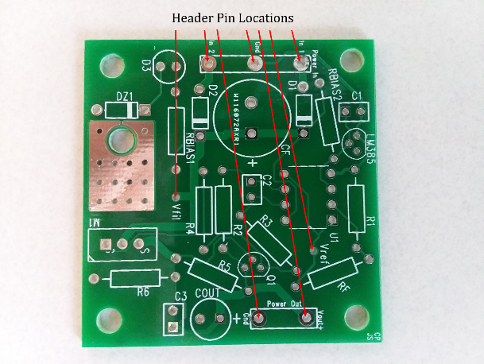A custom printed circuit board (PCB) developed for this DC Power Supply Project is illustrated in **Figure 1**. The arrows in **Figure 1** illustrate the mounting holes for 7 header pins that provide convenient test lead connections to the fully assembled PCB.

**Figure 1:** Custom PCB for DC Power Supply Project with Header Pin Locations Illustrated.

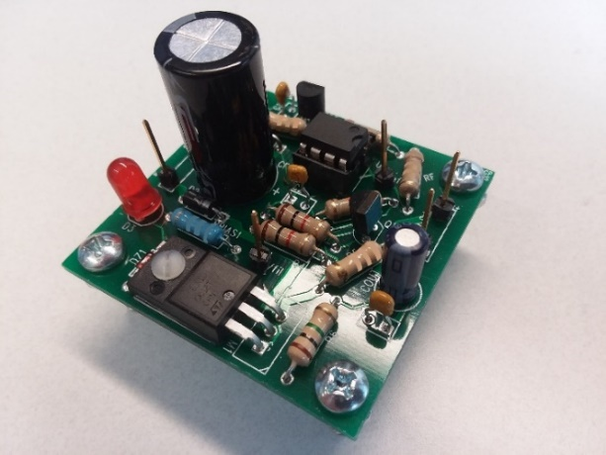An example of a completed DC Power Supply using the custom 2-layer PCB is illustrated in **Figure 2**.

**Figure 2:** Top Side of a Constructed DC Power Supply Using the Custom PCB.

The parts needed for this power supply project are given below in **Table 1**. Notice that a nylon screw and nut are used to bolt down the power transistor, providing for solid mounting and improved thermal resistance. While much of the circuit design along with the overall implementation for this project has been provided, some design decisions remain for you to complete. You are to choose the component values not given in **Table 1**, as explained further in this document. After completing your determination of all components, you are to construct a soldered version of your power supply, like the one illustrated in **Figure 2**. Then upon completion of the construction you are to characterize the performance of your power supply, followed by writing and submitting a report documenting your efforts.

**Table 1:** Parts List and Description for the Home Made DC Power Supply.

|  |  |  |
| --- | --- | --- |
| **Quantity** | **Part Description** | **Location** |
| 1 | 2-Layer Custom PCB | STC 215 |
| 1 | STF80N10F7 N-Channel MOSFET | STC 215 |
| 1 | LM358N Dual Op-amp | STC 215 |
| 1 | 8-pin DIP socket for Dual Op-amp. | STC-215 |
| 1 | LM385-2.5, 2.5 V Voltage Regulator Diode | Engineering Lab Stock |
| 1 | 2N3904 npn transistor | Engineering Lab Stock |
| 1 | (10 – 22) µF 50 V Aluminum Electrolytic Capacitor | Engineering Lab Stock |
| 2 | 0.1 µF Ceramic Capacitor | Engineering Lab Stock |
| 1 | 0.01 µF Ceramic Capacitor | Engineering Lab Stock |
| 2 | 1 kΩ resistors | Engineering Lab Stock |
| 1 | 10 kΩ resistor | Engineering Lab Stock |
| 1 | 1 MΩ resistor | Engineering Lab Stock |
| 1 | Red or Green Power Indicator LED | Engineering Lab Stock |
| 1 | 2-56 x 3/8 inch screw for mounting MOSFET. | Engineering Lab Stock |
| 1 | 2-56 nut for mounting MOSFET. | Engineering Lab Stock |
| 4 | 6-32 x 5/8 inch screws for PCB Legs. | Engineering Lab Stock |
| 4 | 6-32 nuts for PCB Legs. | Engineering Lab Stock |
| 7 | Header pins for convenient test lead connection. | Engineering Lab Stock |
|  | Misc. Resistors, Capacitors and Diodes | Engineering Lab Stock |

### Suggested Design Procedure

The following is the suggested procedure for designing your DC Power Supply, remembering that “**You don’t have time to rush”**.

1. **Become familiar with this DC Power Supply Project Document**,as most project questions asked by students are answered in this document. Using Ctrl + Click allows you to easily navigate this document from the table of contents.
2. Calculate your current limit value, i.e. ILimit based on the thermal resistance of n-channel MOSFET adjustable resistance operating at 50 ˚C maximum ambient temperature.

Tmax­ = 175˚C

Tamb­ = 50˚C

Thermal Resistance = 62.5 ˚C/W

VD est = Vfilterd = 21V

VS = Vref = Vout = 9V

VDS = 12V – R5(IDmax) = 12V – 0.65V = 11.35V

IDmax = (175˚C - 50˚C)/62.5˚C(11.35V)

= 176.2mA

R5 = 0.65V/176.2mA

= 3.689ohm

≈ 3.9ohm

Icalc = 0.1667A

1. Using available standard value resistors, determine the value of current limit resistor R5 to approximately achieve the calculated current limit value. Since standard resistor come in discrete values, you will need to round to the nearest available resistor value. After rounding, re-calculate the expected current limit and use this re-calculated value as the theoretical current limit for your power supply, referred to as Icalc.

Icalc = 0.1667A

1. Calculate the required size of input filter capacitor in order to achieve acceptable input ripple voltage for a load current equal to your calculated current limit value.

Cf = Icalc/(2fVripple)

= 0.1667A/(2(60Hz)1V)

= 1389.1667µF

≈ 1000µF

1. Design and **breadboard** your LED indicator circuitry, verifying proper on/off performance before soldering the associated components to the PCB. **While breadboarding the LED indicator circuitry is recommended to arrive at the correct component values before soldering, most of the rest of the circuitry does not need to be breadboarded since the PCB provides correct connectivity for properly oriented and soldered part.**

ILEDmax =20mA

Vfilterd = 21V

Rbias1 = 9V/20mA = 450ohm

VforwardLED = 2.0V

Zener = 10V

1. Determine the resistor values R1 and Rf necessary to provide the desired reference voltage Vref, where Vref = Vout of the voltage regulator. Vref is to be within ±10% of the desired value with no load applied.

Av = (1 + Rf/R1)

9V/2.5V = 1 + (Rf/R1)

(Rf/R1) = 2.6

Rf = 3.9kohm

R1 = 1.5kohm

1. Solder all components onto the 2-layer custom PCB and verify proper output voltage and current limit and LED indicator performance.
2. Characterize completed DC Power Supply as outlined in the **Performance Characterization** section of this document.
3. Write project report after reviewing the Project Report Grading Rubric previously given in this document.

### Design/Implementation Details

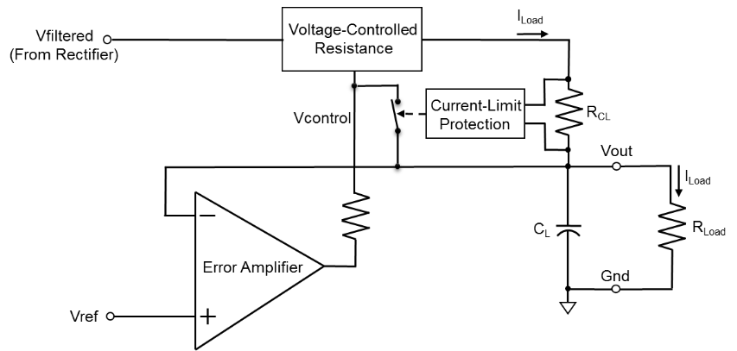A voltage regulator is to be implemented to regulate the output voltage of your power supply to the desired voltage. A voltage regulator maintains a constant output voltage over a wide range of load currents. The adjacent block diagram illustrates the main functional blocks of a voltage regulator with current limit. The input voltage Vfiltered is the filtered voltage from a full-wave rectifier circuit with filter capacitor Cf. The voltage Vref in the adjacent diagram is the reference voltage necessary to achieve a fixed output voltage.

**Figure 3:** Block Diagram of Series Voltage Regulator with Vout = Vref.

Referring to **Figure 3**, the output voltage from the error amplifier controls the resistance of the voltage controlled resistance so that Vout – Vref ≈ 0, i.e. Vout ≈ Vref over a wide range of load resistance values. The error amplifier is to be implemented with an op-amp, with the voltage controlled resistance implemented with a MOSFET transistor. Current-limit protection is necessary so that the voltage regulator will survive overload conditions such as accidentally shorting of the output voltage Vout to ground. In **Figure 3**, the resistor RLoad represents an external load connected that the voltage regulator output.

**Figure 4** below illustrates the complete schematic of the DC Power Supply Project. **You don’t need to include the test points shown in Figure 4 below for your power supply schematic, but** **do need to include your name or names on all your LTspice schematics, using the Text option available in the Edit pull-down menu.** Dual op-amp U1 consists of op-amp U1-A, used in the voltage reference, along with op-amp U1-B, used in the voltage regulator portion. Dual op-amp U1 has power supply connections to Vfiltered and ground. An STF80N10F7 n-channel enhancement mode MOSFET M1 is a power transistor that behaves as a voltage controlled resistor controlled by op-amp U1-B. A VBE current-limit consisting of npn transistor Q1 and resistor R5 is incorporated to protect MOSFET M1 in the event of accidental shorting of the output.

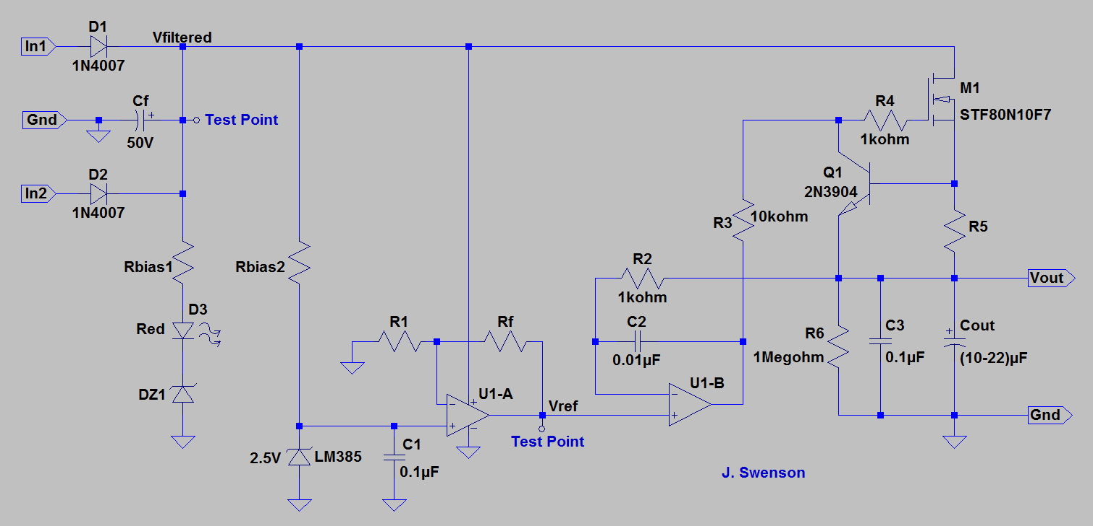

**Figure 4:** Schematic Diagram of the DC Power Supply.

Resistor R4 in series with the gate of MOSFET gate is simply for ESD protection of the static sensitive MOSFET gate terminal. Since the gate input of a MOSFET has essentially infinite input impedance, there is no dc current flow through R4 and therefore no dc voltage drop across this ESD protection resistor. For the n-channel enhancement mode STF80N10F7 MOSFET M1, an increase in the Gate-to-Source voltage (VGS) decreases the Drain-to-Source resistance, and vice versa for a decreasing VGS.

For your power supply it is necessary to calculate a current limit that will not overheat MOSFET M1. For this calculation assume the TO-220FP through-hole package for the MOSFET, along with an ambient temperature TA of 50 ˚C. Use the specified maximum junction temperature of the STF80N10F7 n-channel MOSFET from the datasheet, along with a conservative estimate of the drain-to-source voltage across the MOSFET, approximating as necessary. Measured results from the center tapped transformer output previously measured for Diode Rectifier Lab can be used to obtain an approximate worst-case (maximum) dc value for Vfiltered for this current limit calculation. Also assume a regulator output voltage equal to Vref for your current limit calculation, rather than Vout = 0 V, which would be the case for a shorted output condition. With this approach, the STF80N10F7 transistor should survive regulated output operation of Vout = Vref for years of operation, while surviving a shorted output condition for at least several hours, which is sufficient for this project. After calculating your current limit value, it is necessary to determine the value of the current limit resistor R5 based on the relationship (0.65 V)/ILimit. Since only discrete values of resistors are available, it is necessary to select the closest value to your calculated value, then re-calculate the actual ILimit value based on the actual resistor value used for R5. The re-calculated value, referred to as Icalc, is to be used later when comparing with measured current limit performance in **Table 2**.

Referring to **Figure 4**, resistor R6 provides a resistive path to ground for small leakage currents associated with MOSFET M1 when no external load resistance is connected to the output of the voltage regulator.

The voltage reference portion of the power supply illustrated in **Figure 4** consists of an LM385-2.5, 2.5 V voltage regulator diode along with bias resistor Rbias2. This resistor should be chosen to provide a reverse breakdown current through the LM385-2.5 voltage regulator diode ranging from 100 µA to 1 mA. The LM385-2.5 provides a constant 2.5 V as input to the non-inverting amplifier configuration consisting of U1-A, Rf and R1. Choose R1 and Rf to produce the desired Vref voltage while keeping the maximum output current of op-amp U1-A < 2 mA. Rf and R1 should be chosen to achieve the desired voltage Vref ±10%. Datasheets for the STF80N10F7 n-channel MOSFET, LM358N Op-amp and LM385-2.5 voltage regulator diode can be accessed from the Student Project folder in I-learn.

1mA = 18.5V/Rbias2

Rbias2 = 18.5V/1mA

Rbias2 = 18.5kohm = 20kohm

1. Referring to **Figure 4**, components Rbias1, D3, along with Zener diode DZ1 constitute the LED power indicator. The LED for this power indicator should turn-on (becomes visibly lighted) in the range of 12 V < Vin ≤ 15 V.The value for Rbias1 is to be chosen based on allowing sufficient current to turn on the LED power indicator while not consuming more than 20 mA for this indicator circuit. **While breadboarding the LED indicator circuitry is recommended to arrive at the correct component values before soldering, most of the rest of the circuitry does not need to be breadboarded since the PCB provides correct connectivity for properly oriented and soldered parts.**

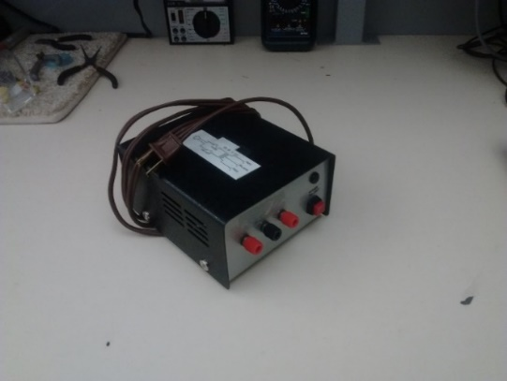Your DC Power Supply is to accommodate either AC or DC input power. Use the center tapped transformer illustrated in **Figure 5** for AC input power and a standard adjustable DC power supply for DC input power for your DC Power Supply. There are to be three power input connections for your project, one for the Red1 transformer output connector, one for the Black transformer center tap (ground) connector and one for the Red2 transformer output connector. Your supply can be powered from a DC voltage supply simply by connecting the positive output of the DC supply to either the Red1 or Red2 inputs with the ground of the DC supply connected to the center tap transformer ground point on your circuit board.

**Figure 5:** Center Tapped Transformers to Power Your DC Power Supply.

Use a diode full-wave rectifier for a center-tapped transformer, as constructed in the Rectifier Lab, for the rectification necessary when powered from the AC center tapped transformer. A large filter capacitor (Cf) is to be added to the output of your diode full-wave rectifier in order to reduce the voltage ripple to suitable levels. The value of this filter capacitor is to be calculated based on **acceptable ripple voltage at the maximum load current**. Strive for a maximum ripple voltage that is in the range of (0.5 to 2) V peak-to-peak. Ripple voltages larger than 2 V pk-pk can result in poor regulator ripple-rejection performance, whereas ripple voltages less than 0.5 V pk-pk at the maximum load current require excessively large filter capacitor values (> 2000 µF). Use **Equation 1** below to calculate your filter capacitor value Cf, using your re-calculated theoretical current limit value Icalc for the current, and 60 Hz as the frequency f. (See Equation B.7 from Appendix B of the Boylestad and Nashelsky text assuming that Vdc/Vm = 1):

An aluminum electrolytic (polarized) capacitor with a 50 V rating is needed for filter capacitor Cf. From the capacitors available in STC-215, choose one having a value reasonably close to your calculated value. After choosing Cf, re-calculate the expected peak-to-peak voltage ripple based on the actual capacitor value used. Then scale this value by 0.9, in order to arrive at the expected peak-to-peak voltage ripple at a load current of 0.9Icalc, i.e. 90% of the current limit value, used to characterize input and output voltage ripple. Then enter your 0.9Icalc value in **Table 2** below for comparison against measured input voltage ripple value.

### Performance Characterization

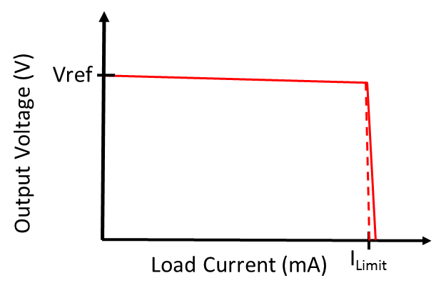**In order to provide the best results, all performance characterization measurements are to be taken after the PCB assembly, including component soldering, has been completed.** You are to characterize the regulation and current limit performance of your DC Power supply and provide a graph of measured output voltage versus load current in the **Measured Voltage Regulator Performance** section of your report. Your graph should have the general shape as illustrated in **Figure 6**, and is to include axis labels along with a figure number and caption. Points will be deducted for graphs illustrating non-functional performance.

**Figure 6:** Output Voltage versus Load Current for a DC Voltage Regulator with Current Limit.

To arrive at your output voltage versus load current graph, measure the output voltage for various external resistive loads, including no load, i.e. 0 mA load current, a load current of approximately 90% of your recalculated ILimit value, along with some load current values > ILimit so as to characterize the current limit performance. For the various resistive loads, estimate the load current using the indicated load resistance value and Ohm’s Law. The Ohm’s Law approach becomes inaccurate for indicated resistance values < 10 Ω because of non-negligible wiring resistance. Hence **a minimum load resistance of 10 Ω is recommended for your output voltage versus load current characterization**. Since the standard available resistors are only rated for 0.25 W, power resistors (≥ 0.5 W) of values 100 Ω, 33 Ω, 22 Ω and 4.3 Ω are available in the STC 215 parts bins to aid in this output voltage versus load current graph. Various series and parallel combinations of these power resistors can be used to provide multiple data points for load resistance values < 100 Ω. Alligator clip test leads along with separate alligator clips can be used to connect up necessary power resistor combinations to characterize your power supply current limit performance, as illustrated in **Figure 7** below.

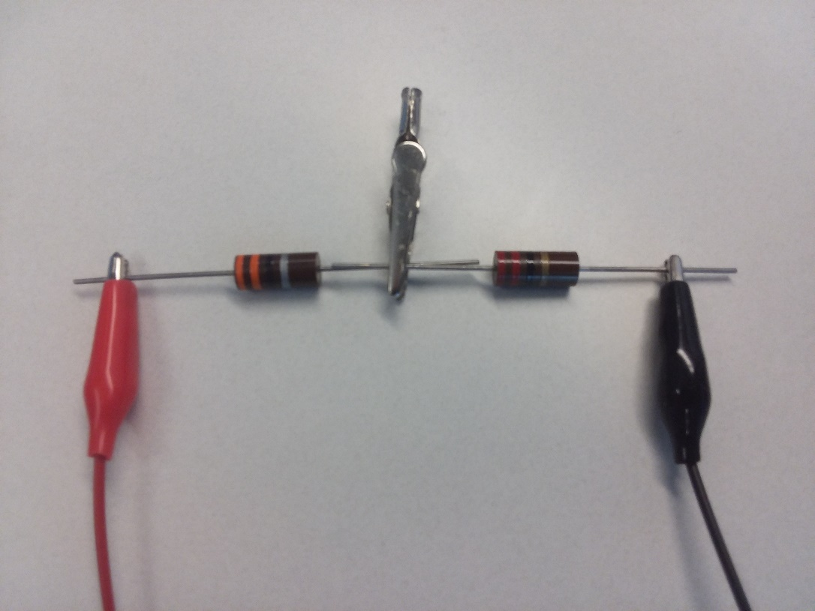

**Figure 7:** Illustration of Connecting a 33 Ω Power Resistor in Series with a 22 Ω Power Resistor as a Load.

You are also to characterize 120 Hz ripple rejection performance of your DC Power supply using the VirtualBench oscilloscope. The full-wave rectification of the 60 Hz signal, results in a 120 Hz ripple on Vfiltered. A useful figure-of-merit for voltage regulators is ripple rejection, and can be quite good (large) at 120 Hz. A good voltage regulator responds fast enough to greatly reduce the 120 Hz peak-to-peak ripple voltage appearing on the regulated output compared to the ripple voltage magnitude on the regulator input. **Since ripple voltage from your full-bridge rectifier circuit increases with increasing load current, a measurement of ripple rejection depends upon load current, and is to be done at approximately 90% of your actual current limit value**.

Using a 2-channel oscilloscope, the ripple rejection of your completed DC Power Supply is to be measured when AC powered by the center-tapped transformer with ILoad ≈ 0.9ILimit. The 2-channel oscilloscope is to be used to determine peak-to-peak input voltage ripple, i.e. ∆Vfiltered, along with the peak-to-peak output voltage ripple, i.e. ∆Vout. Since ∆Vfiltered/∆Vout should be much greater than 1 for a properly performing voltage regulator, Ripple Rejection should be a positive number. After measuring ∆Vfiltered and ∆Vout, the ripple rejection is to be calculated as follows:

∆Vfiltered and ∆Vout can both be viewed simultaneously on the oscilloscope by using two channels, with the larger ∆Vfiltered channel for the trigger. For both ∆Vfiltered and ∆Vout, AC coupling is necessary to remove the large DC voltages, therefore allowing for improved vertical resolution. By utilizing AC coupling on the VirtualBench 2-channel oscilloscope, small AC ripple on ∆Vout can be viewed on a 10 mV/Division input range utilizing a 1X oscilloscope probe and associated input channel setting. The following waveforms illustrate VirtualBench oscilloscope measurements of ∆Vfiltered and ∆Vout of a properly constructed DC Power Supply using a 10X probe for ∆Vfiltered (Red) and a 1X probe for ∆Vout (Yellow).

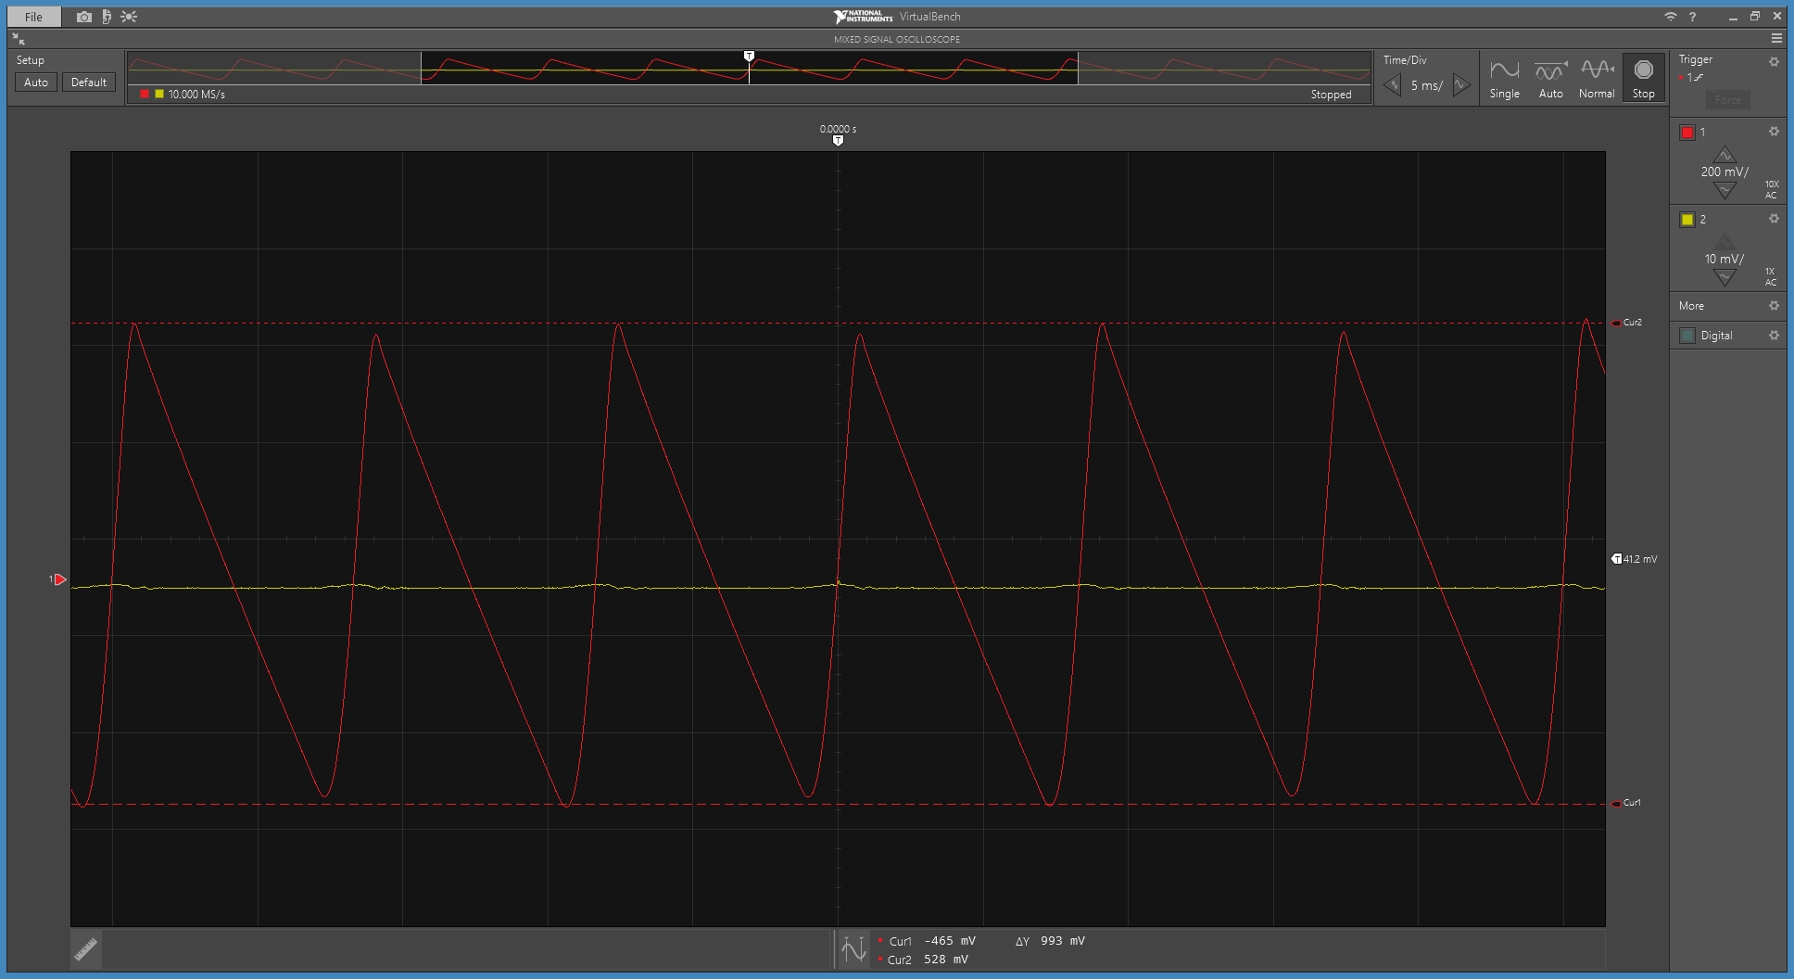

**Figure 8:** Input Voltage Ripple Measurement of a DC Power Supply. Cursors Set to Measure ∆Vfiltered on Channel 1 (Red), resulting in ∆Y = ∆Vfiltered = 993 mV pk-pk.

The ∆Vout ripple on this properly constructed DC Power Supply performance illustrated in **Figures 8 & 9** is < 1 mV peak-to-peak, making it difficult to accurately measure. **Figure 9** illustrates the ∆Vout peak-to-peak measurement utilizing the voltage cursors available with the VirtualBench oscilloscope. Measurement averaging on the VirtualBench 2-channel oscilloscope was invoked by means of an option menu located in the upper right hand corner for the Mixed Signal Oscilloscope for the waveforms shown in **Figure 9**. Selecting the **Acquisition** option, provides averaging options with **128 averages** recommended for this ripple rejection measurement in order to reduce random measurement noise.

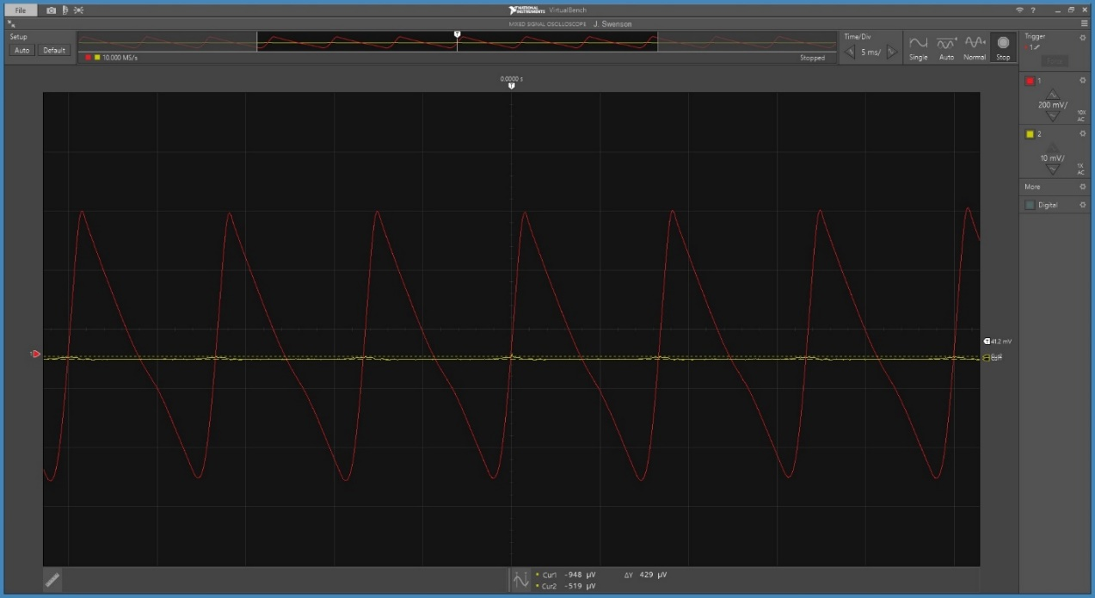

**Figure 9:** Output Voltage Ripple Measurement of a DC Power Supply. Cursors Set to Measure ∆Vout on Channel 2 (Yellow), resulting in ∆Y = ∆Vout = 429 µV pk-pk. Noise Reduced on Channel 2 (Yellow) by Averaging 128 Measurements.

Based on the above measured ∆Vfiltered and ∆Vout values, a ripple rejection number of is calculated for the DC Power Supply performance illustrated in **Figures 8 & 9**. This is a factor of (993 mV)/(429 µV) = 2315, indicating that the op-amp is able to greatly reject the 120 Hz ripple on Vfiltered.

After successfully characterizing and calculating the ripple rejection of your DC Power supply, include your calculated ripple rejection in dB in **Table 2** below. Also include an oscilloscope screen capture of your measured output voltage ripple at approximately 90% of your current limit, like the one illustrated in **Figure 9** above with the cursors set to measuring the peak-to-peak output voltage ripple. For this measurement utilizing waveform averaging and a 1X probe, in the **Measured Voltage Regulator Performance** section of your report, including a figure number and caption. Your screen capture should be wide enough to include the CH. 1 and CH. 2 settings control so that a 1X probe setting can be verified for the displayed output voltage ripple.

In addition to your output voltage versus load current graph and ripple rejection, you are to further characterize the performance of your DC Power supply by completing the measurements and calculations listed in **Table 2** below. Replace the valid ranges given in blue in **Table 2** with your specific measured values, including your completed **Table 2**, along with a table number and caption, in the **Measured** **Voltage Regulator Performance** section of your report.

For your measured current limit value, refer to your graph of output voltage versus load current, with the current limit being the minimum current that noticeably causes the output voltage to fall out of regulation. Using the percent error calculation described in **Table 2**, determine the percent error between your measured current limit value and the calculated value Icalc re-calculated based on the actual resistor value used for R5.

**Table 2**: Measured Voltage Regulator Performance Parameters.

|  |  |
| --- | --- |
| **Parameter** | **Measured Values** |
| Measured Current Limit Value (mA). | 100 mA< ILimit < 200 mA |
| Percent error between measured and calculated current limit value, with % Error = (100)(Imeas – Icalc )/(Icalc). | Within ±20% of Icalc using actual R5 value |
| Calculated input voltage ripple for 0.9Icalc. | < 2.5 V pk-pk |
| Measured input voltage ripple (∆Vfiltered) for the output loaded at approximately 90% of current limit (Vpk-pk). | < 2 V pk-pk |
| Measured output voltage for no external load. (V). | Vref ±10% |
| Measured output voltage for regulator loaded at approximately 90% of current limit. (V) | Vref ±20% |
| 120 Hz Ripple Rejection in dB at 90% of current limit. | ≥ 54 dB |
| DC input voltage which turns on your LED indicator (V). | 12 V < Vin ≤ 15 V |

You are to include the above table with your measured performance parameters in the **Measured Performance** section of your project report.